Math Reviewer
The Law of Sines
Law of Sines:
- Law of Sines – A formula used to find unknown sides or angles of a triangle when the given has 2 triangles already. When you know an angle-side opposite pair. It works for all triangles, especially ASA, AAS, and SSA (ambiguous case).
Formulas:  $$\frac{SinA}{a}=\frac{SinB}{b}=\frac{SinC}{c}$$  $$Angle 3=180-(Angle 1+Angle 2)$$  $$\overline{AC}=B , \overline{AB}=C , \overline{CB}=A$$  $$Uppercase Letters=Angles$$  $$Lowercase Letters=Sides$$ | 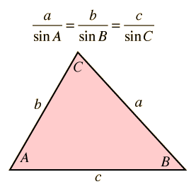

Steps in Finding the Missing Angles of Sides:
Finding a Side:  $$\frac{SinA}{a}=\frac{SinB}{b}$$  $$abc=\frac{a\left(sinB\right)}{sinA}$$ | Finding an Angle:  $$∠ ABC=\frac{a\left(sinB\right)}{sinA}$$  $$∠ ABC=sin^{-1}\left(\frac{bsinA}{a}\right)$$ | Finding the Last Angle:  $$∠ ABC=180-(∠ A+∠B)$$

The Six Trigonometric Ratios:
- Trigonometric Ratios – Trigonometric ratios describe the relationship between angles and side lengths in a right triangle.
- Sine $(sin θ)$ – The ratio of the Opposite side to the Hypotenuse in a right triangle.
- Cosine $(cos θ)$ – The ratio of the Adjacent side to the Hypotenuse.
- Tangent $(tan θ)$ – The ratio of the Opposite side to the Adjacent side.
- Cosecant $(csc θ)$ – The reciprocal of sine, ratio of Hypotenuse to Opposite.
- Secant $(sec θ)$ - The reciprocal of cosine, ratio of Hypotenuse to Adjacent.
- Cotangent $(cot θ)$ - The reciprocal of tangent, ratio of Adjacent to Opposite.
SOH-CAH-TOA | CHO-SHA-CAO
$$sinθ=\frac{Opposite}{Hypotenuse}$$ | $$cscθ=\frac{Hypotenuse}{Opposite}$$
$$cosθ=\frac{Adjacent}{Hypotenuse}$$ | $$secθ=\frac{Hypotenuse}{Adjacent}$$
$$tanθ=\frac{Opposite}{Adjacent}$$ | $$cotθ=\frac{Adjacent}{Opposite}$$
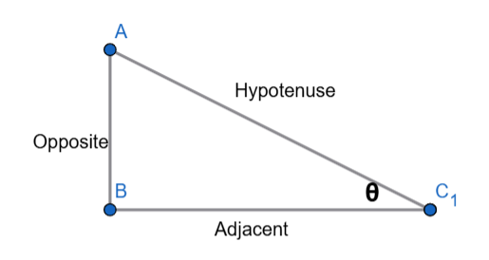 | 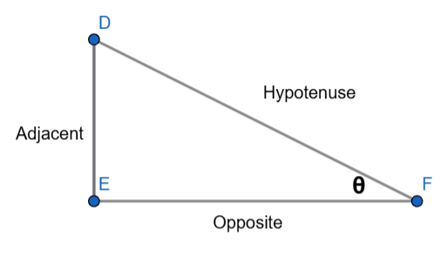
THIS IS NORMAL | (THETA SHOULD BE AT TOP)

Reciprocal Definition Rules
$$csc\left(θ\right)=\frac{1}{sin\left(θ\right)}$$ | $$sec\left(θ\right)=\frac{1}{cos\left(θ\right)}$$ | $$cot\left(θ\right)=\frac{1}{tan\left(θ\right)}$$

Triangle Congruence Theorems:
Postulate/Theorem: | Full Name: | Given Parts: | Type:
SSS | Side-Side-Side | 3 sides | Postulate
SAS | Side-Angle-Side | 2 sides + included angle | Postulate
ASA | Angle-Side-Angle | 2 angles + included side | Postulate
AAS | Angle-Angle-Side | 2 angles + non-included side | Postulate
SSA | Side-Side-Angle | 2 sides + non-included angle | Postulate
HL | Hypotenuse-Leg | Hypotenuse + 1 leg (right triangles) | Theorem

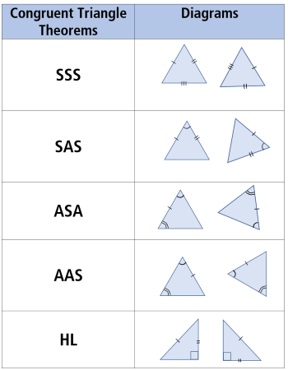

Types of Triangles:
- Triangle – A fundamental polygon in geometry consisting of three straight sides and three angles.
- Oblique Triangle – Any triangle that is not a right triangle which could be an acute triangle or obtuse triangle.
- Obtuse Triangle – Has one angle greater than 90°.
- Acute Triangle – All 3 angles are less than 90°.
- Right Triangle – Has one triangle that is exactly 90°.

Ambiguous Case (SSA Case):
- Ambiguous Case – Occurs when two separate triangles can be constructed from the data provided. Happens when we are given two sides and an angle that is not included between the two sides.
- Height – The perpendicular distance from any vertex to the opposite side or base.
$$h=bsinA​$$

Conditions
If Acute: |  | If Obtuse:
$$a<h$$ | 0 Triangle | $$a≤b$$ | 0 Triangles
$$a=h$$ | 1 Right Triangle
$$h<a<b$$ | 2 Triangles | $$a>b$$ | 1 Triangle
$$a≥b$$ | 1 Triangle
Examples of Solving Oblique Triangles:
Example 1:
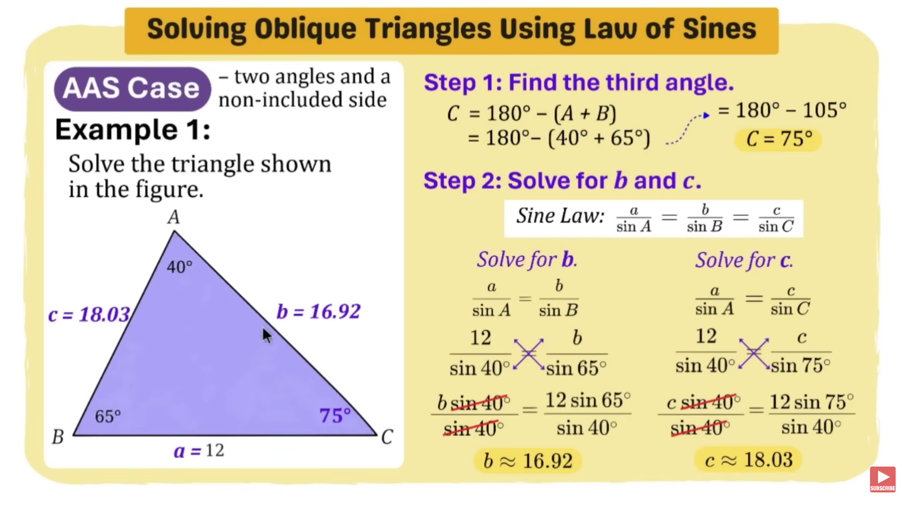
Example 2:
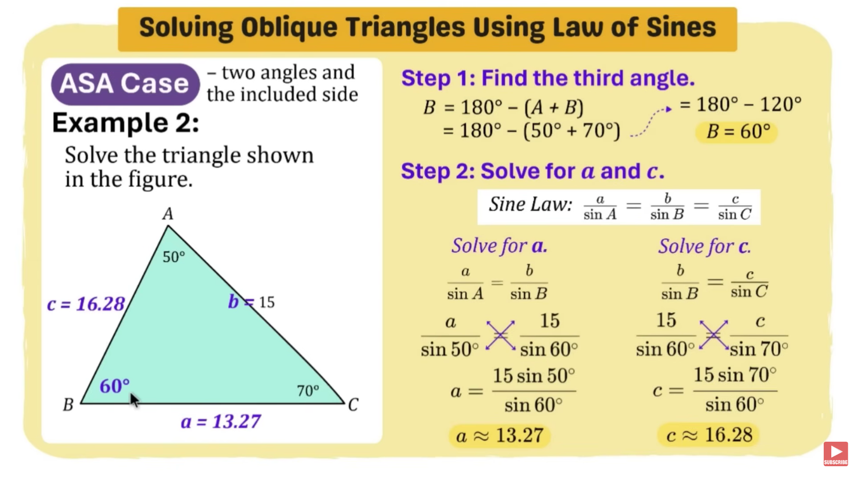

Examples of Solving Ambiguous Case Triangles:
Example 1:
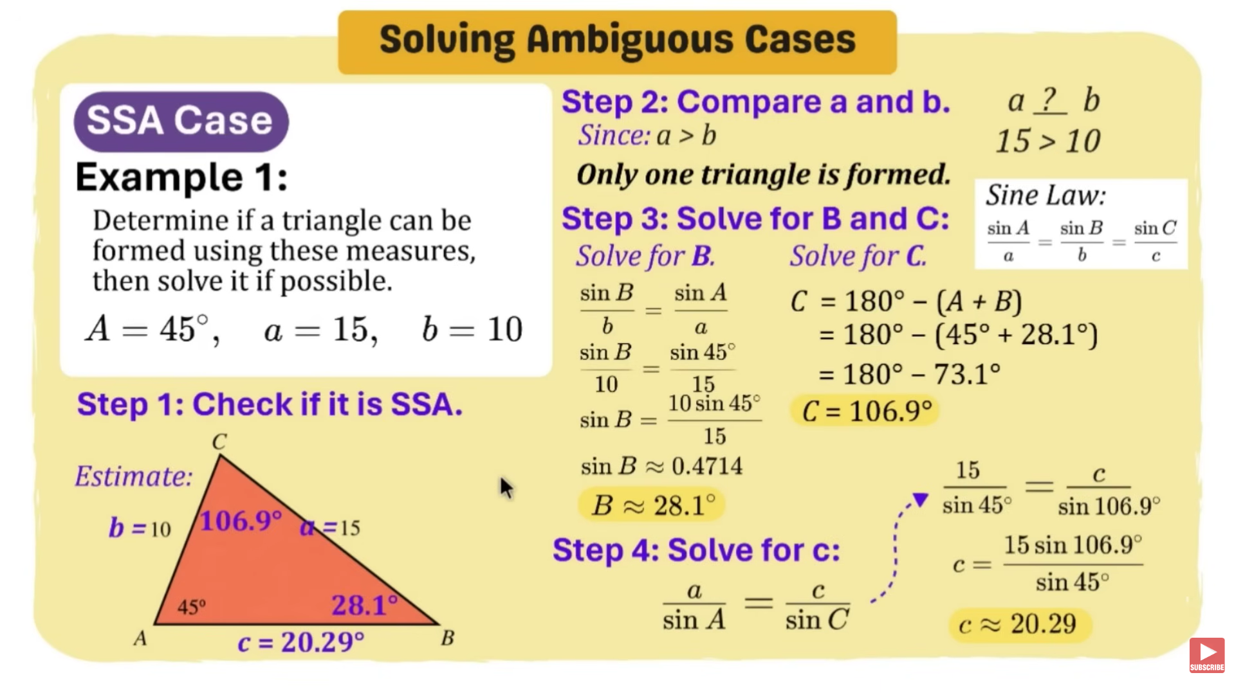
Example 2:
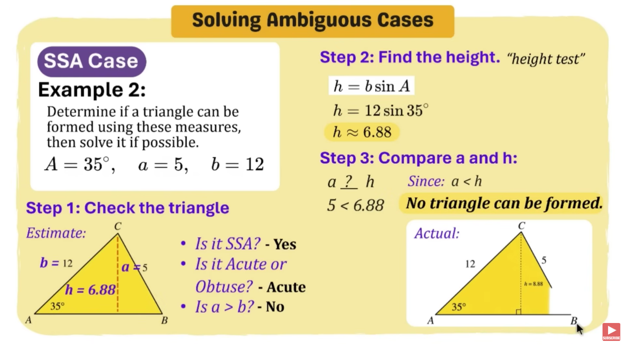
Example 3:
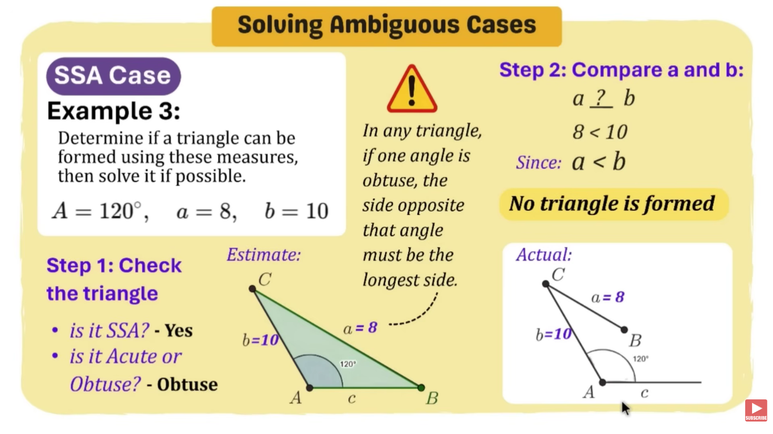
Example 4:
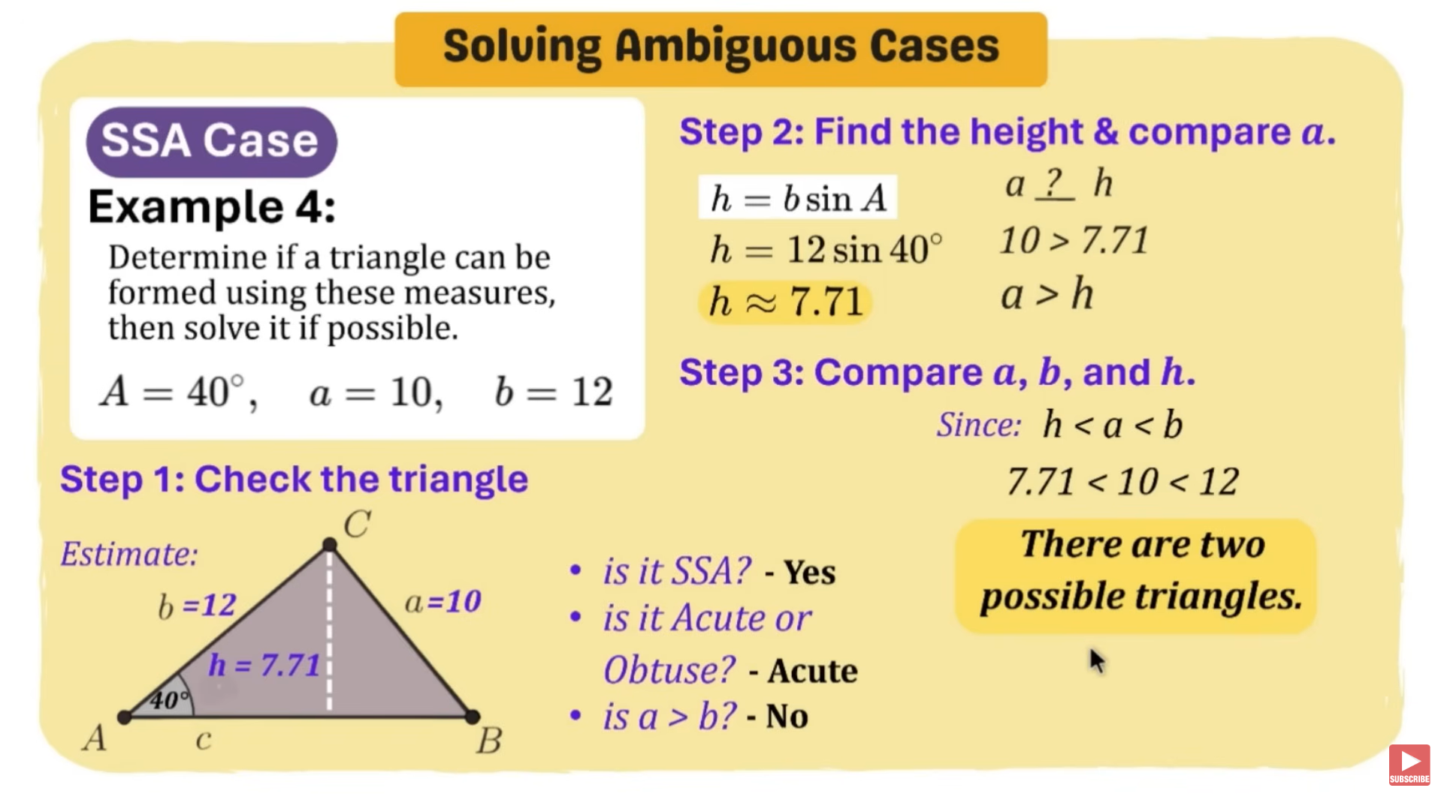
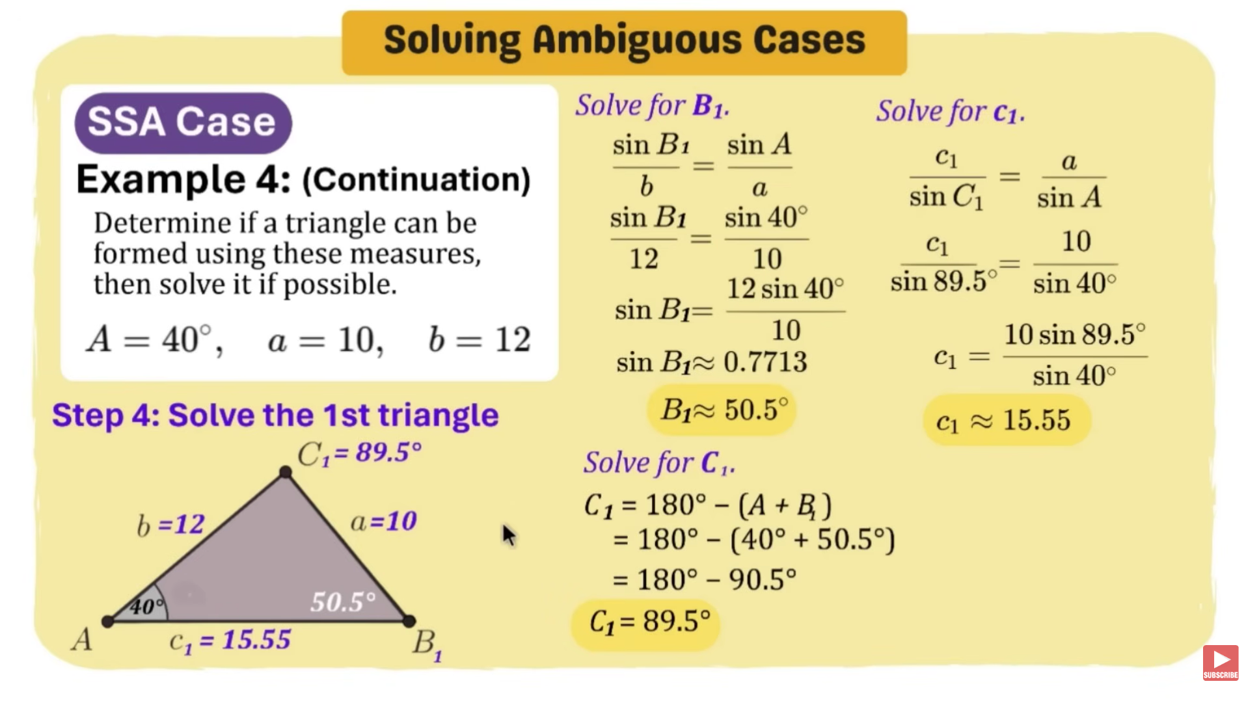
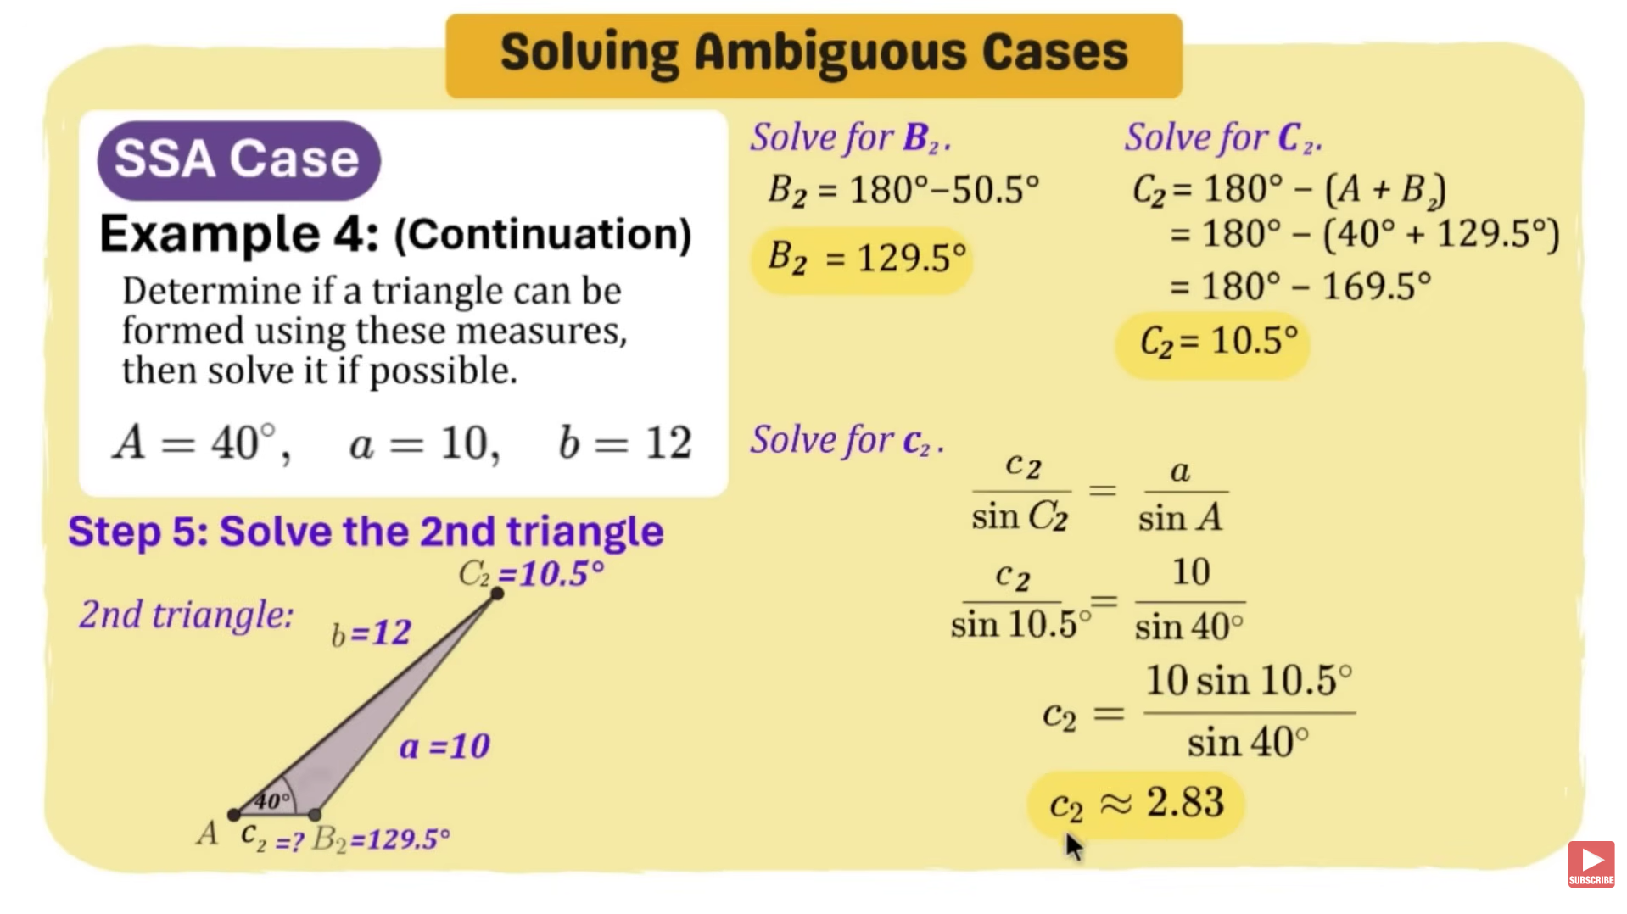
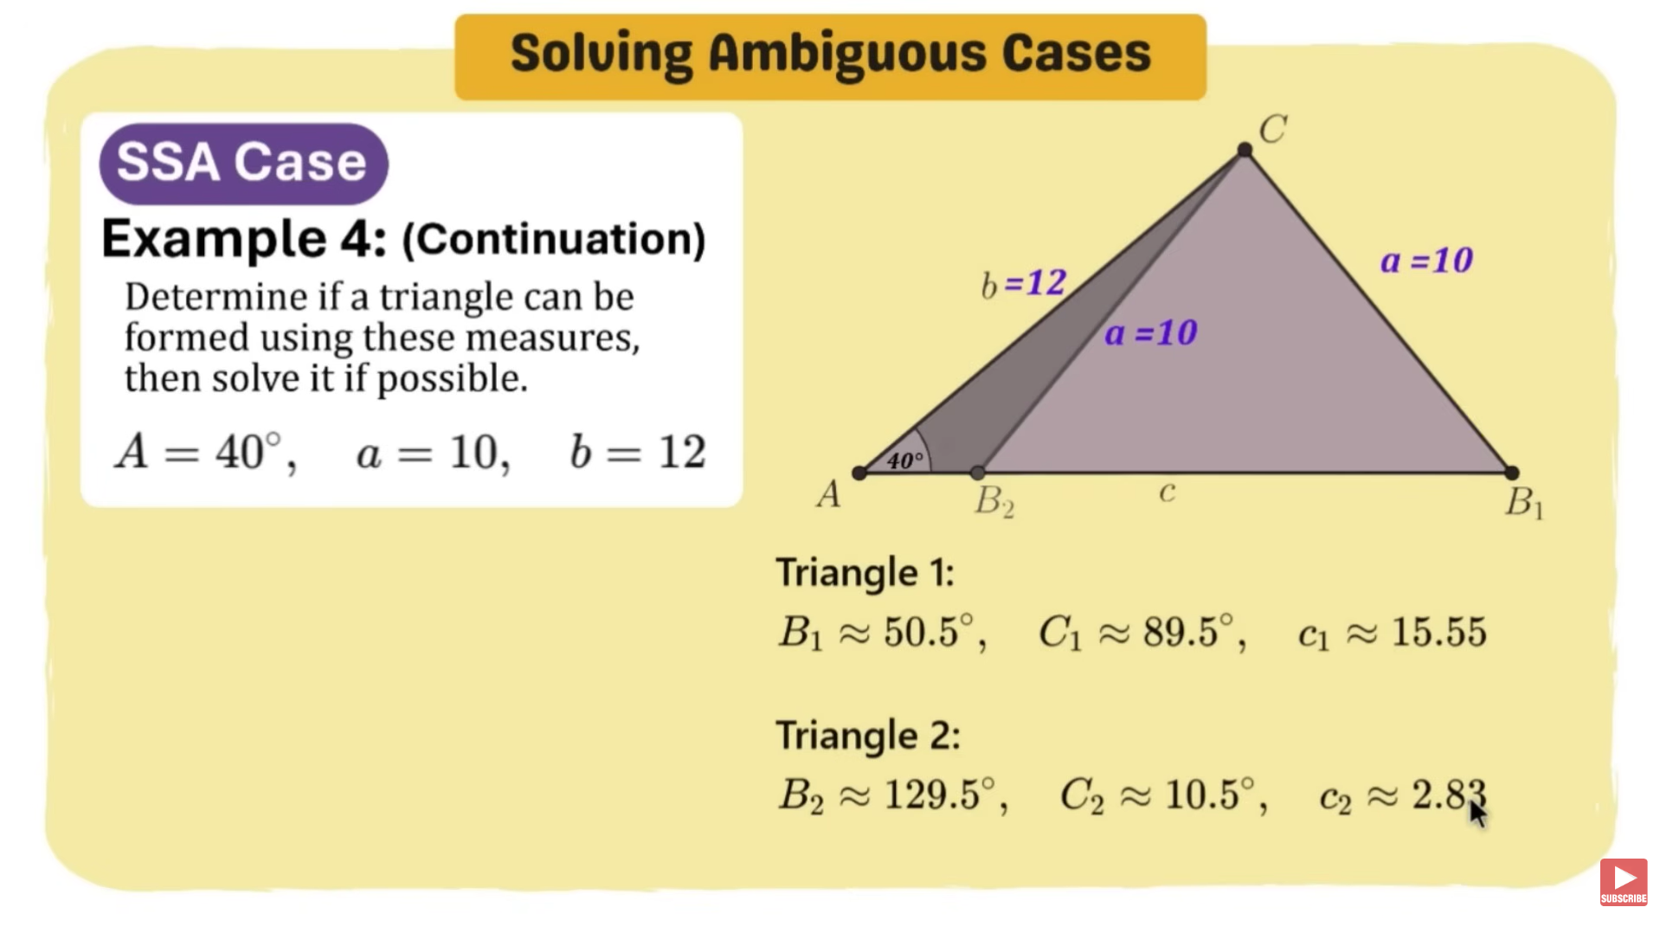

Law of Cosines
Law of Cosines:
- Law of Cosines – A formula used to find an unknown side or angle of a triangle when you know two sides and the included angle (SAS) or all three sides (SSS). It is an extension of the Theorem for all triangles.
Formula for Sides: | Formula for Angles:
$$a^{2}=\sqrt{(b^{2}+c^{2})-(2bc)(\cos{A})}$$  $$b^{2}=\sqrt{\left(a^{2}+c^{2}\right)-\left(2ac\right)(\cos{B})}$$  $$c^{2}=\sqrt{{(a}^{2}+b^{2})-(2ab)(\cos{C})}$$ | $$A=\cos^{-1}\left(\frac{b^{2}+c^{2}-a^{2}}{2bc}\right) \\ B=\cos^{-1}\left(\frac{a^{2}+c^{2}-b^{2}}{2ac}\right) \\ C=\cos^{-1}\left(\frac{a^{2}+b^{2}-c^{2}}{2ab}\right)$$

Example 1:
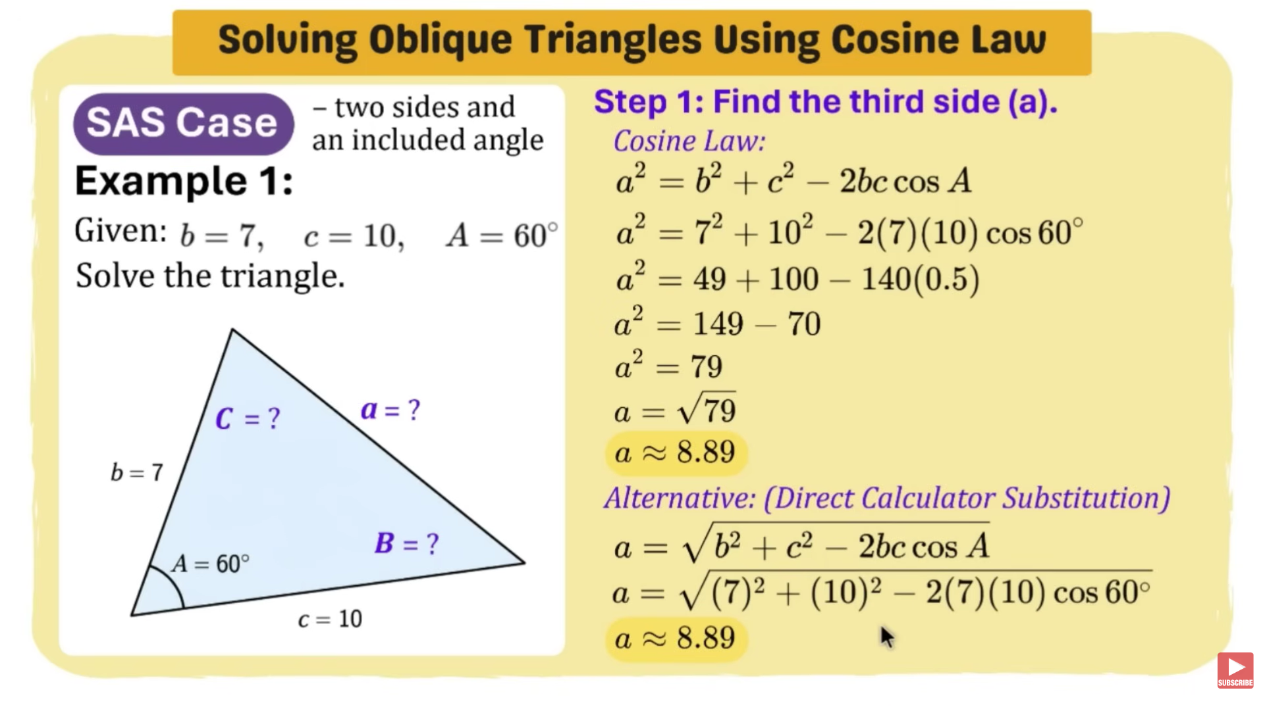

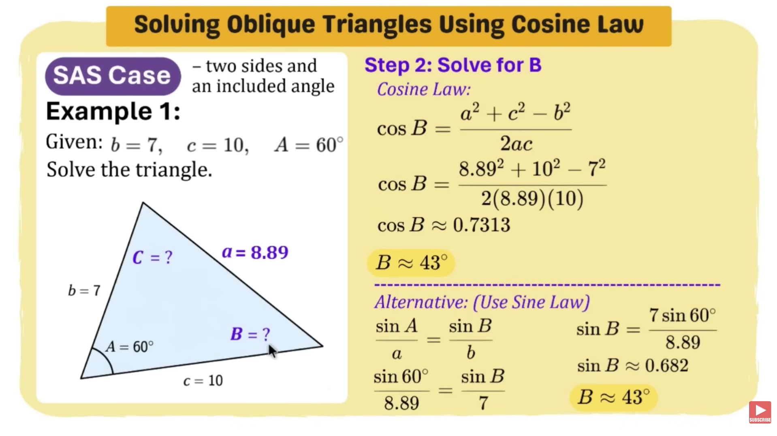

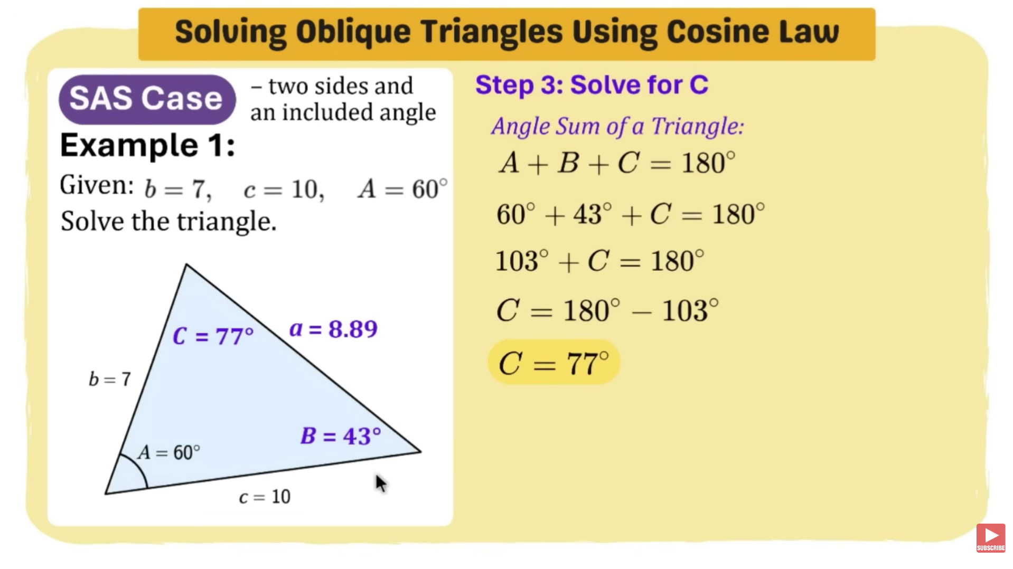

Example 2:
